

DEPARTMENT OF

"BACHELOR BUSINESS ADMINISTRATION (COMPUTER APPLICATION)" NESS WADIA COLLEGE OF COMMERCE, PUNE

ACADEMIC YEAR 2023-24

SEMESTER-IV

PROJECT REPORT

ON

***"STRATI FOOTBALL "***

**SUBMITTED TO**

SAVITRIBAI PHULE PUNE UNIVERSITY

**SUBMITTED BY**

Shivam Kale (23)

Piyush Bangdekar (68)

**UNDER THE GUIDANCE OF**

Prof. LEENA THORAT

Prof. VAISHALI CHILWAR

Prof. ANITA PATIL

ACKNOWLEDGEMENT

We would like to express our sincere gratitude to all those who have contributed to the success of this college project.

A project for a student is an experience, in the course of which he/she realizes the real-world problems that one has to undergo during the development of any project. Hence without the help and guidance of our teachers, this project wouldn't have been successful.

Firstly, we would like to thank our project supervisor **Prof. LEENA THORAT** and **Prof. VAISHALI CHILWAR** for providing us with guidance and support throughout the development process.

We would also like to thank our college faculty and staff for providing us with the necessary resources and facilities to complete this project. Additionally, we would like to thank all the individuals who participated in the user testing and provided valuable feedback for improving the project. I sincerely acknowledge the help of the entire staff of the Bachelors in Computers Application Department and our classmates whose cooperation has made our project a success.

Finally, we would like to acknowledge the support of our families and friends who have provided us with the necessary motivation and encouragement to complete this project.

Thank you all for your invaluable contributions.

**Yours Sincerely,**

**SHIVAM KALE**

**PIYUSH BANGDEKAR**

ABSTRACT

In regions with limited internet connectivity and a need for data conservation, the demand for web-based entertainment experiences remains underserved. This abstract presents an innovative solution: a web-based football game designed to function seamlessly on low internet speeds while offering strategic depth and engaging gameplay. The game's architecture prioritizes efficient data usage without compromising on interactive features or gameplay dynamics. Key components of the game include a lightweight user interface optimized for quick loading times and minimal data consumption. Utilizing compressed assets and client-side processing techniques, the game delivers high-quality graphics and animations while minimizing bandwidth requirements. Advanced AI algorithms enable strategic gameplay experiences, providing players with challenging opponents and realistic match scenarios. Offline capabilities allow for uninterrupted gaming sessions, storing essential game data locally to reduce reliance on internet connectivity. Additionally, the game's design fosters strategic thinking and tactical decision-making, offering players opportunities to refine their football strategies and skills. By addressing the need for low-internet-speed entertainment options, this web-based football game serves as a testament to the potential of technology in providing inclusive and accessible gaming experiences for diverse audiences worldwide.

INDEX

|  |  |  |
| --- | --- | --- |
| **No.** |  | **Title Page No.** |
| **1.** | 1.1  1.2  1.3  1.4 | **Introduction**  Problem Statement  Purpose of the project  Project scope and Limitations |
| **2.**  **3.** | 2.1  2.2  2.3 | **System Analysis**  Existing System  Drawbacks of existing system  Features  **Feasibility Study** |
| **4.** |  | **Implementation Details**  Software Requirements  Hardware Requirements |
| **5.** |  | **System Design**  ER Diagram  DFD (Data Flow Diagram)  Mathematical concept |
| **6.** |  | **Screenshots** |
| **7.** |  | **Bibliography** |

1. INTRODUCTION

In today's digital age, online entertainment has become ubiquitous, offering a vast array of options to cater to diverse interests and preferences. However, amidst the proliferation of online gaming platforms, there exists a significant segment of the global population with limited internet access and constrained data resources. In regions where internet connectivity is unreliable or data usage is costly, accessing online entertainment poses a considerable challenge. Recognizing this disparity, there arises a pressing need for innovative solutions that can provide engaging experiences while accommodating low internet speeds and data limitations. In response to this challenge, we introduce a groundbreaking concept: a web-based football game meticulously crafted to operate seamlessly under such conditions. This introduction sets the stage for exploring the development of a game that not only transcends connectivity barriers but also offers strategic depth and immersive gameplay experiences. By leveraging the power of web technologies and prioritizing efficiency in data usage, this game aims to redefine the landscape of online entertainment, making interactive gaming accessible to a wider audience regardless of their internet connectivity constraints. Through this endeavor, we embark on a journey to bridge the digital divide and foster inclusive gaming experiences for all.

* 1. PROBLEM STATEMENT

In a world where internet connectivity varies widely and data usage comes at a premium, there is a growing demand for web-based entertainment experiences that are accessible, nostalgic, and immersive while requiring minimal data and low internet speeds. Traditional online gaming platforms often fail to cater to this need, either due to their heavy reliance on data-intensive graphics and features or their lack of depth and strategic gameplay. Moreover, individuals seeking nostalgic experiences reminiscent of classic football games may find themselves underserved in the current gaming landscape dominated by high-definition, resource-heavy titles. Recognizing these challenges, there is an evident gap in the market for a web-based football game that combines the simplicity and nostalgia of classic gameplay with innovative strategies, all while minimizing data usage and accommodating low internet speeds. Addressing this gap requires the development of a game that seamlessly integrates lightweight graphics, intuitive controls, and strategic gameplay mechanics, providing players with a captivating and accessible gaming experience that evokes feelings of nostalgia while fostering strategic thinking and skill development.

1.2 PURPOSE OF PROJECT

The purpose of this project is to develop a web-based football game that addresses the need for nostalgic, easy-to-play gameplay while accommodating low data usage and internet speeds. By creating a game that combines the simplicity and familiarity of classic football games with innovative strategic elements, the aim is to provide players with an engaging and immersive gaming experience that transcends connectivity barriers. This game seeks to evoke feelings of nostalgia while also challenging players to employ strategic techniques, fostering skill development and enjoyment regardless of internet access limitations. Ultimately, the purpose of this project is to bridge the digital divide by offering a nostalgic yet modern gaming experience that is accessible to a wider audience, including those with limited internet connectivity and data resources.

1.3 PROJECT SCOPE AND

LIMITATIONS

Scope:

The scope of this project encompasses the design, development, and deployment of a web-based football game optimized for low data usage and internet speeds. This includes conceptualizing game mechanics, designing intuitive user interfaces, implementing lightweight graphics and animations, integrating strategic gameplay elements, and ensuring compatibility across various web browsers and devices. The game will offer multiplayer mode , providing opportunities for social interaction. Features such as offline capabilities, customizable controls, and accessibility options will be included to enhance the user experience. Additionally, the project may involve user testing and iteration to refine gameplay mechanics and optimize performance.

Project Limitations:

Despite its ambitious scope, this project also has several limitations. Firstly, due to resource constraints, the game's graphics and animations may be limited in complexity compared to high-definition, resource-intensive titles. Similarly, while efforts will be made to minimize data usage and accommodate low internet speeds, the game's performance may still be affected in regions with extremely limited connectivity. Additionally, the scope of the project may not allow for the implementation of advanced features or extensive content updates post-launch. Furthermore, compatibility issues may arise on older devices or less commonly used web browsers, which may limit the game's accessibility to certain users. Finally, while the game aims to evoke feelings of nostalgia, it may not fully replicate the experience of classic football games due to modern design considerations and technical constraints.

2.SYSTEM ANALYSIS

2.1 EXISTING SYSTEM

There are several existing web-based football games that cater to various preferences and requirements. Some of these games prioritize lightweight design, nostalgic gameplay, and accessibility while accommodating low data usage and internet speeds. One example is "New Star Soccer," a popular web-based football simulation game that combines simple graphics with addictive gameplay, making it suitable for users with limited internet connectivity and data resources. Another example is "Soccer Stars," a multiplayer game that offers a minimalist design and intuitive controls, allowing players to engage in quick matches against opponents worldwide without requiring high bandwidth. Additionally, browser-based versions of classic football games like "Sensible Soccer" and "Football Manager" provide nostalgic experiences for fans of retro gaming, often with streamlined graphics and simplified gameplay mechanics. These existing games demonstrate the feasibility of developing web-based football games that cater to users with low data and internet speeds while offering engaging and accessible gameplay experiences.

2.2 Drawbacks of existing system

● Limited Graphics and Features: Many existing games prioritize lightweight design to accommodate low data usage and internet speeds. As a result, they may lack high-definition graphics, advanced animations, and immersive visual effects found in more resource-intensive games.

● Minimal Offline Capabilities: While some existing games offer offline play options, the offline capabilities may be limited in scope or functionality.

● Compatibility Issues: Despite efforts to ensure compatibility across various devices and web browsers, some existing games may encounter compatibility issues on older devices or less commonly used platforms. .

2.3 Features

➢ Lightweight Design

➢ Offline Capabilities

➢ Multiplayer Mode

3.FEASIBILITY STUDY

A feasibility study for a web base football game would typically assess the technical, economic, and operational viability of the project. Here are some considerations for each of these areas:

● Technical Feasibility:

The project appears technically feasible given the availability of web

technologies and frameworks optimized for low bandwidth usage and

cross-platform compatibility. Implementing lightweight graphics,

client-side rendering, and progressive loading techniques should enable

the development of a web-based football game capable of functioning

smoothly on devices with limited resources and internet connectivity.

● Economic Feasibility:

developing a web-based football game involves careful consideration of development costs, revenue streams, operating expenses, and market dynamics. Initial investment in development must be balanced against potential revenue sources, such as advertisements and in-app purchases.

● Operational Feasibility:

The operational feasibility of the project hinges on factors such as team capabilities, development timelines, and scalability. Ensuring that the development team possesses the requisite skills and experience in web development and game design is essential. Establishing realistic development milestones and timelines, as well as scalability plans to accommodate potential growth in user base and content updates, would contribute to operational feasibility.

4. IMPLEMENTATION DETAILS

4.1 SOFTWARE REQUIREMENTS

**Front End**: HTML, CSS, Java script

**Back End**: Java script (J query library), Java script local storage

**Platform**: Windows 10, Visual Studio, Note pad, Google Chrome, Microsoft Edge

4.2 HARDWARE REQUIREMENTS

The minimum requirements of hardware are as follows

RAM: 2GB

Monitor.

Limited Internet connection.

5. SYSTEM DESIGN

System Design is the first step into the development phase for any engineered product or system. Design is a creative process. A good design is the key to an effective system. The term "design" is defined as "the process of applying various techniques and principles for the purpose of defining a process or a system is sufficient".

5.1 ER DIAGRAM

ER diagrams are used in database design to represent the structure of a database system. They provide a visual representation of entities (objects), their attributes (properties), and the relationships between entities.

● Entities: Entities are objects or concepts in the real world that can be uniquely identified and stored in a database. Each entity is represented by a rectangle in an ER diagram and is label with its name.

● Attributes: Attributes are characteristics or properties of an entity. They describe the data that can be associated with an entity. Attributes are depicted as ovals or ellipses connected to their corresponding entity rectangle.

● Relationships: Relationships illustrate the associations between entities. They represent how entities are connected or related to each other. Relationships are represented by diamonds or rhombuses in an ER diagram, and they are label to describe the nature of the relationship (e.g., one-to-one, one-to-many, many-to-many).

**FOLLOWING IS THE ER-DIAGRAM OF THE SYSTEM**

# “STRATI-BALL”

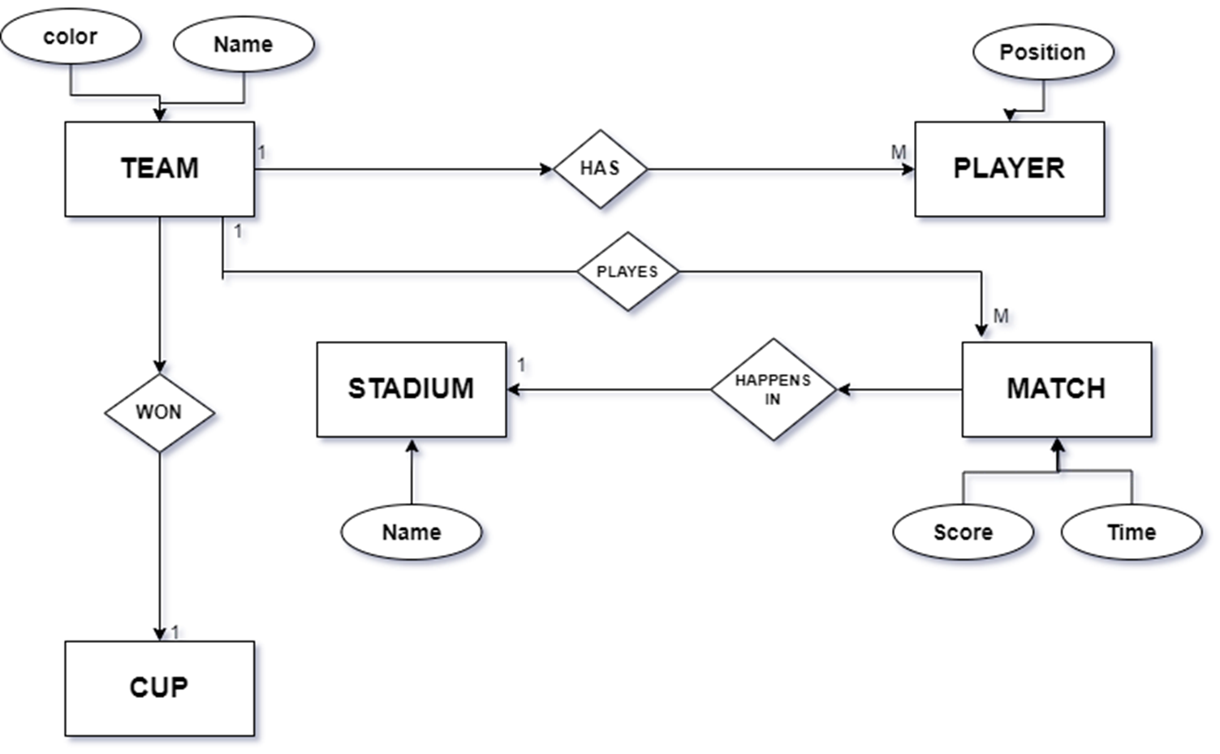

5.2 DATA FLOW DIAGRAM

A Data Flow Diagram (DFD) is a graphical representation of the flow of data within a system or process. It illustrates how data is input, processed, stored, and outputted. DFDs are commonly used in systems analysis and design to understand and communicate the data flow and processes involved in a system.

**Context Level DFD:**

● A Context Level Data Flow Diagram (DFD), also known as a Level 0 DFD. ● It provides an overview of the entire system or process being modeled. ● It illustrates the interactions between the system and external entities, without going into the internal details of the system.

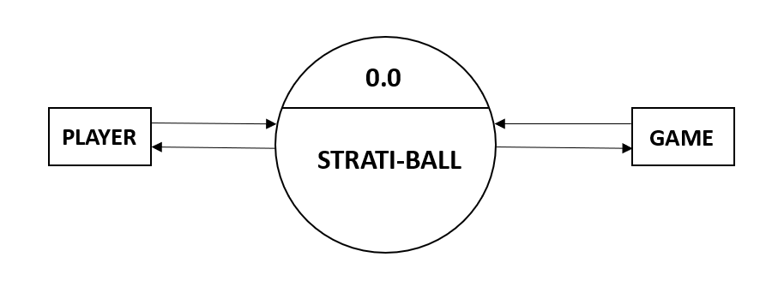

**First Level DFD:**

● The Level 1 Diagram further decomposes each major process from the Level 0 Diagram into sub-processes or subprocesses.

● It provides a more detailed view of the system's functionality and the data flows between the processes.

● The Level 1 Diagram may also show data stores where data is stored temporarily or permanently.

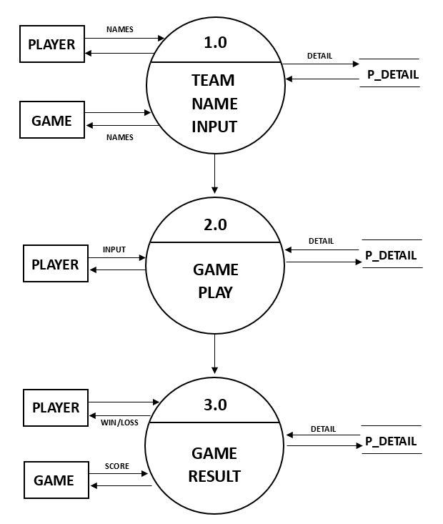

6.SCREENSHOTS

5.3 MATHEMATICAL CONCEPTS

**PYTHAGORAS THEOREM:**

Pythagoras theorem states that in right triangle, The square of the length of the Hypotenuse

Is equal to sum of squares of the length of the other two sides it is fundamental principal of geometry. We have used this concept to find the distance between players.

(Hypotenuse)2 = A2 + B2

**PYTHAGORAS THEOREM:**

In a parametric representation of a line, a point is said to lie on the line if its coordinates satisfy the parametric equations of the line. These equations express the x and y coordinates of any point on the line in terms of one or more parameters. By substituting the coordinates of the point into these equations and solving for the parameters, you can determine if the point lies on the line. If the parameters satisfy the equations, the point lies on the line; otherwise, it does not. This method provides a concise and efficient way to verify the position of a point relative to a line.

paraX=aX+ratio*(bX-aX);

paraY=aY+ratio*(bY-aY);

1)HOME PAGE

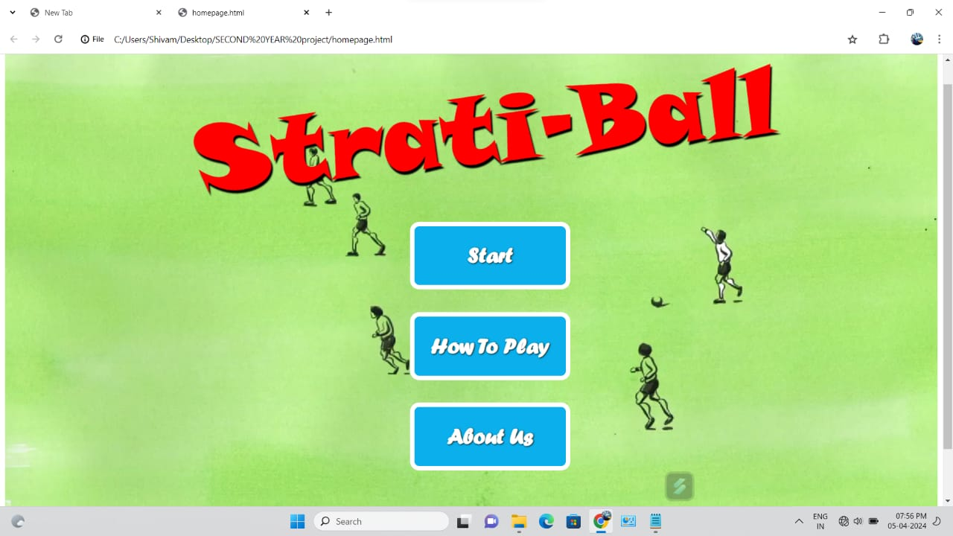

2)TEAM REGISTRATION (TEAM NAME)

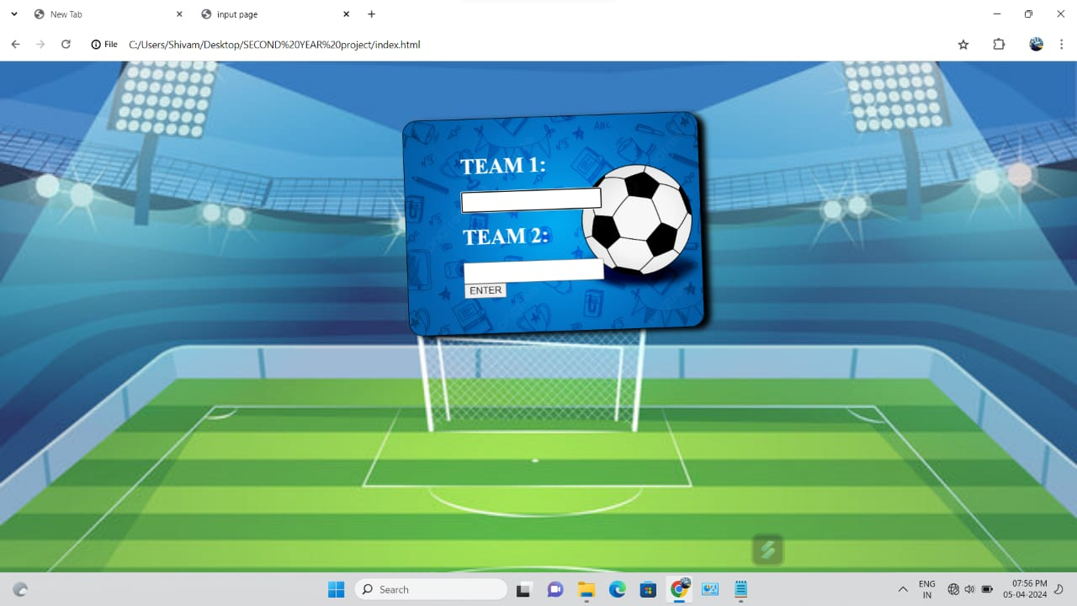

3) GAME PLAYER POSITION

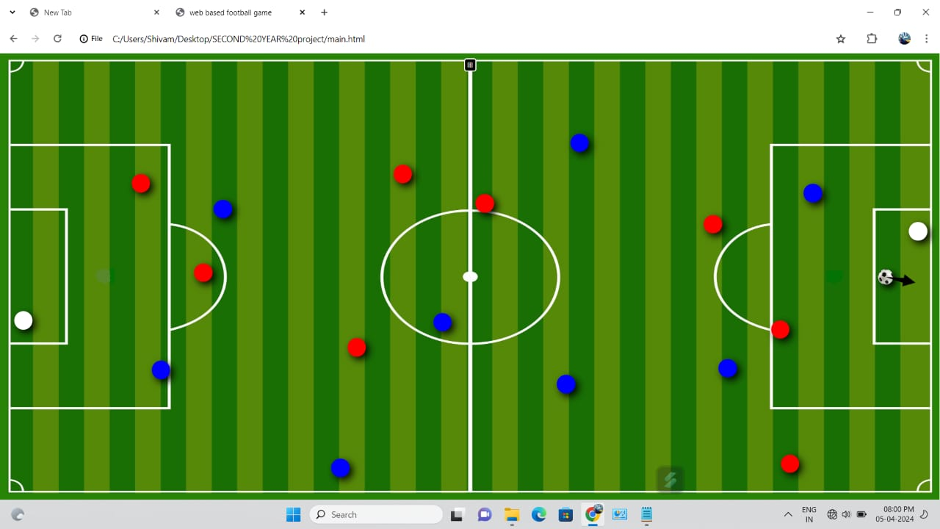

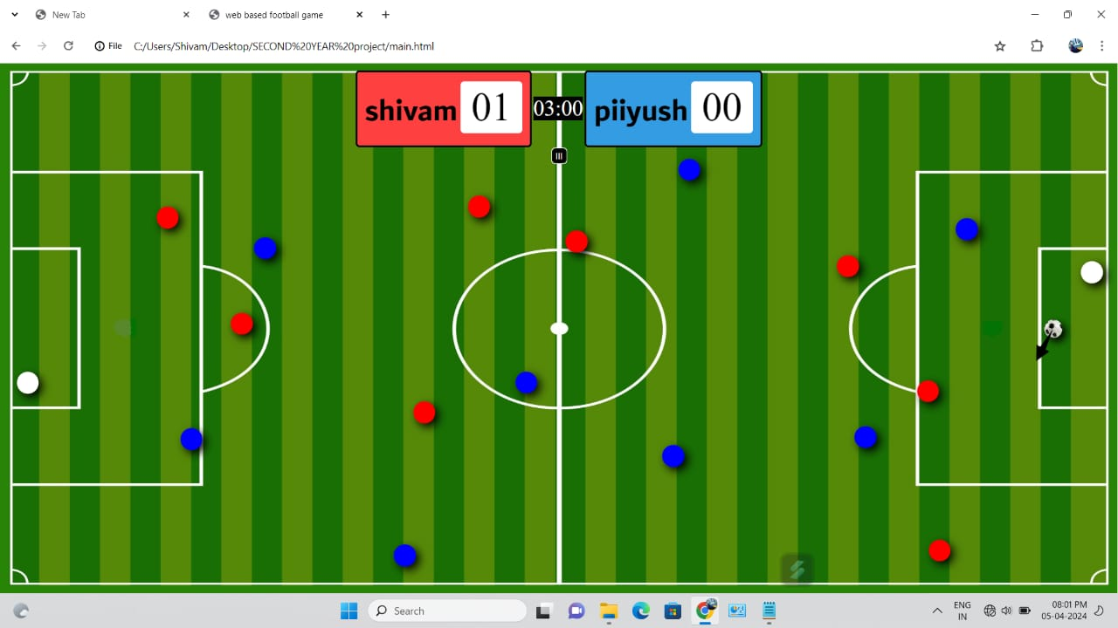4) WHEN A TEAM HIT GOAL

5) ABOUT PAGE



6) How to Play

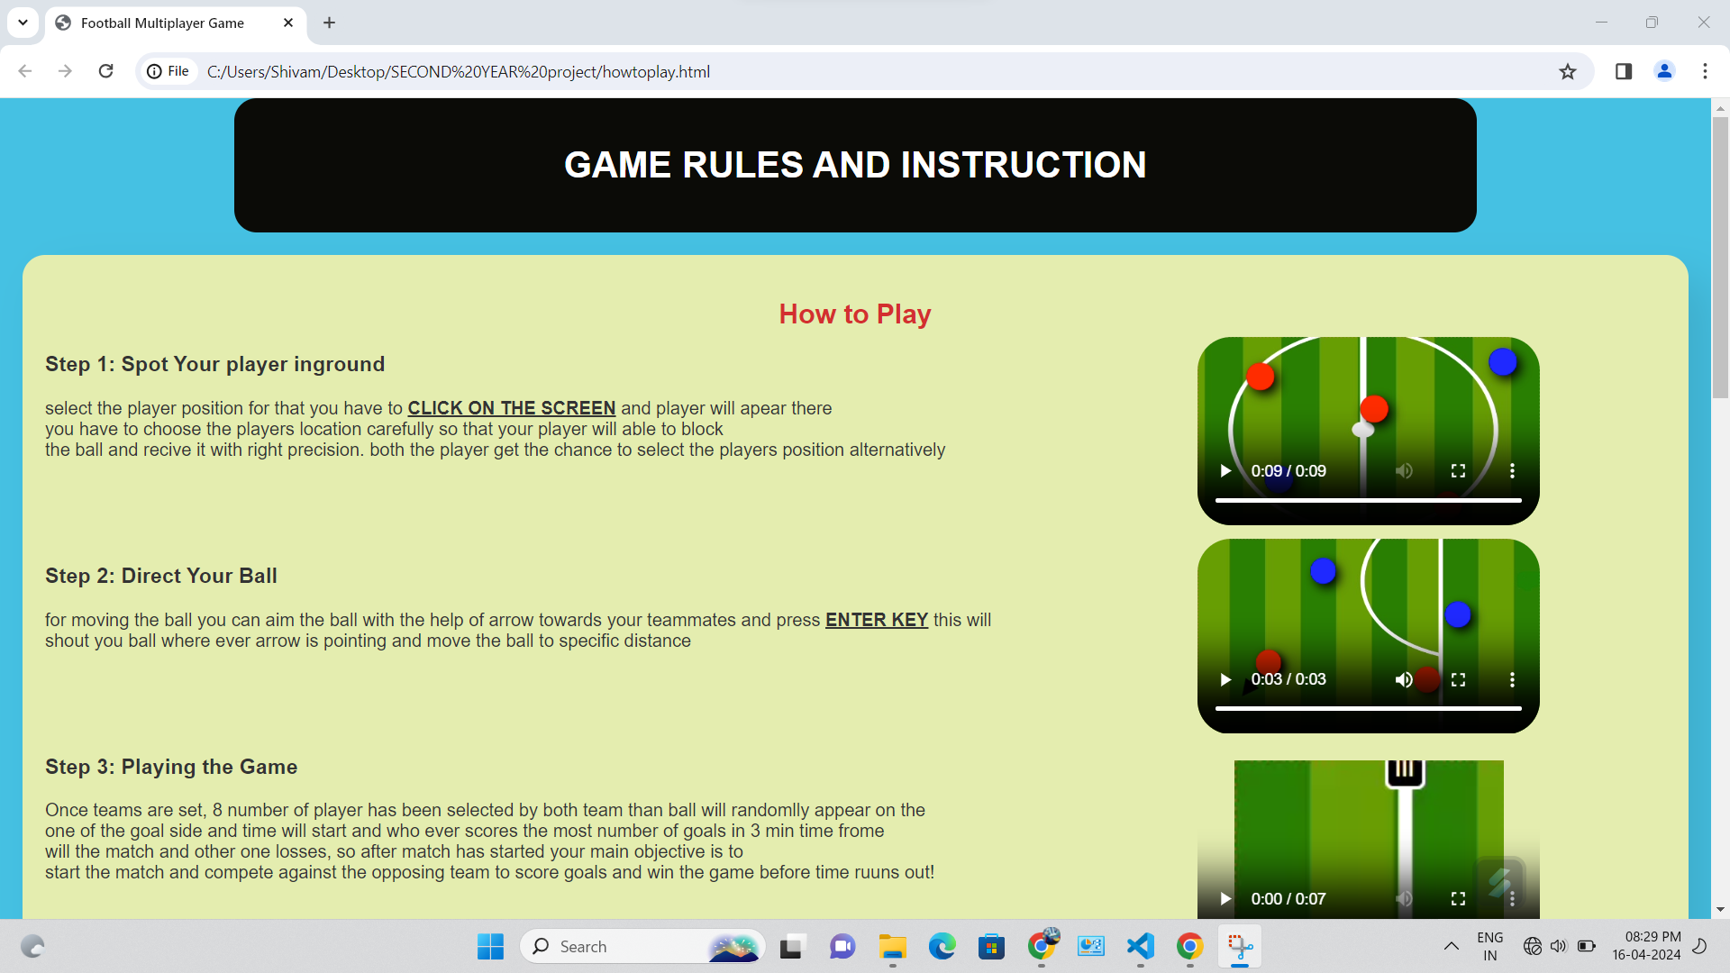

7) Game Rules

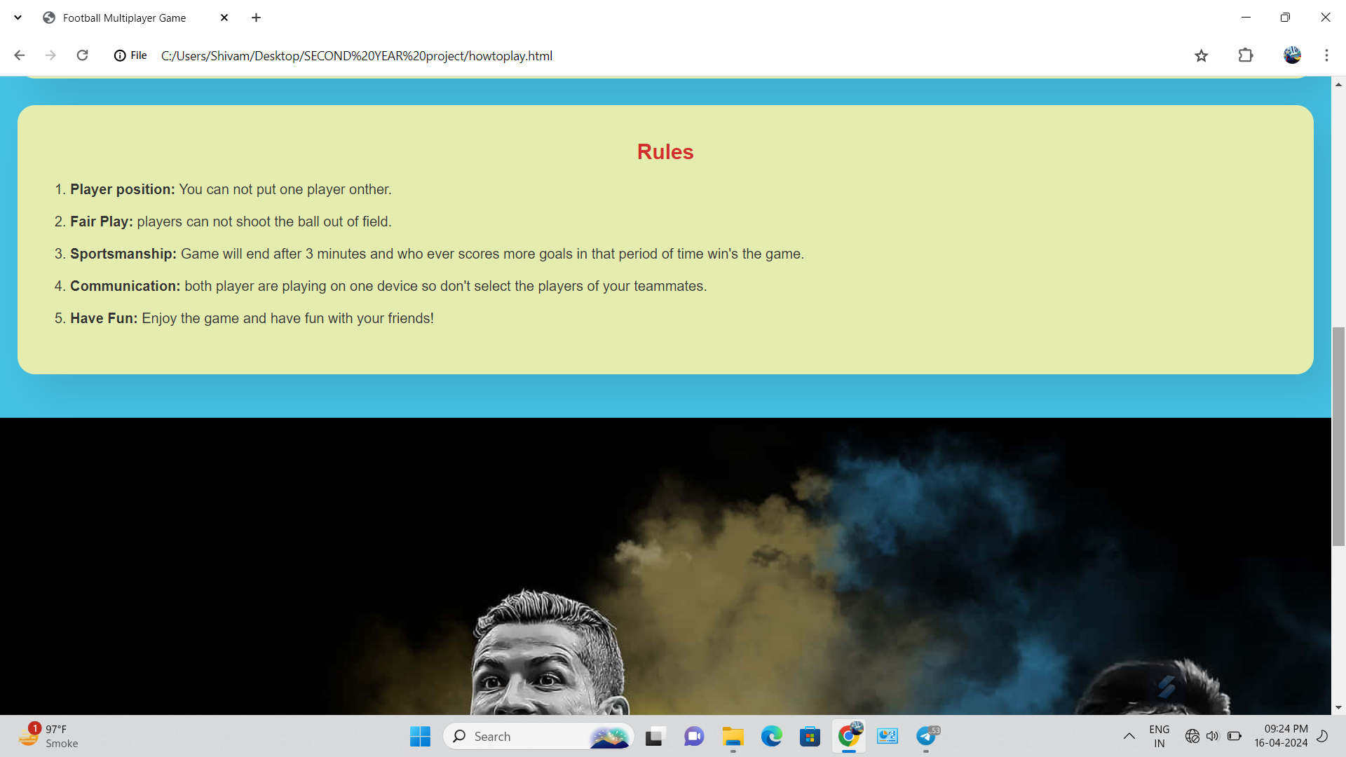

7.BIBLIOGRAPHY

❖Using Open AI’s API

❖Website: https://openai.com

❖Learning JavaScript,HTML,CSS

❖Website: https://youtube.com